Water Presentation Summary

My name's Russ Rodocker and I'm superintendent of your water department. I want to start always by thanking the staff. Specifically, Josh Kudlacek, Bryanne, and Billy. Billy and Josh are the ones that work predominantly in the field, doing all the general maintenance, the well readings and things of that nature.

Bryanne works in our office, and she has some specialties in regards to the fact that she's done some studies relating to the water department. When a call comes in, she has those calls answered, before it has to come to me, or if it even has to come to me, so I really appreciate the staff and all their help.

I'll start a little bit with the capital projects for this year. We had several of them. One of them was revamping the injection panel system in both wells’ control panels area. 3 and 7 is completely finished, and we're waiting for the scheduling on well number 4 to be done. This is in reference to the injection system for the sodium hydroxide. We replaced the 2007 Sprinter van with a 2019 Sprinter van that worked out really well. It's all retrofitted. We do everything in-house. And, so we have a good, reliable, emergency response vehicle. That's our primary emergency response vehicle for anything in the system, whether it be a main break, a well that went down. All the equipment's stored in that one van, including parts and everything, so it's a critical piece of equipment for us.

The other thing we've been working on year after year is the water rights. All documents have been submitted to Department of Ecology. I got a response back from them just last week that they accepted them, which doesn't mean approved. They accepted all the documents that I sent in. They're estimating about 18 months to review the documents. And when I talk about what we're asking the Department of Ecology to do for us is when the founders of the community club went out and got water rights, they did it so that each well or a couple wells has a group of water rights attached to it. So, Riviera has 356 acre-feet of water rights, but they would say, you can have 70 from these two wells, you can have 50 from this well. That makes it very complicated, because we're not going to need all nine wells, right? We have some wells that only produce 20 gallons a minute which is not worth putting online. We have one well that the water quality isn't so good so we don’t use that one. What I've done is I've approached Department of Ecology with, hey, put them all in one bank, but list all our wells and all 356 acre-feet in one bank of water rights, so that we choose where we draw the water rights from, from whichever well we want. And it’s going to be critical in the future, because we'll need that for connection purposes. If it got down to where there are a few wells that literally wouldn't do us any good, we couldn't draw the water rights that were written for it. So, if we wanted to eventually access all 356 feet, we would need all this put together. The timing was right to approach this. Legislation is constantly battling the ability to deal with water rights. Luckily, with RH2 Engineering and myself, we had a pre-meeting, and ecology seemed to be on board with what I'm trying to do, so now it's just the wait game.

On another great note this year, Bryanne and Billy went in and did a water competition this year for best tasting, clarity, smell as well as some other categories. Well, we took first place. And the first place was in what they call the South Puget Sound region, that's Kitsap County, Pierce County, Mason County, Grays Harbor, Thurston County, and Pacific County. So out of all those water systems that went into the competition, and we got a first-place trophy out of the deal.

I want to take the opportunity to explain a little bit on the water rights, because I know this sometimes can be a little confusing. This is our pumping.

This is how much gallons per year, that we're pumping in water, and I put some specifics on that. This year, we pumped 52.4 million gallons of water. And to compare that to last year, we were about 3.6 million gallons more pumped this year than we did in 2024, about a 7% increase. I think predominantly, we can all say that's most likely due to the fact that we had a really long summer and heat this year. I think that's what brought the usage up, including heavy use on the irrigation side. That's what usually causes our increase.
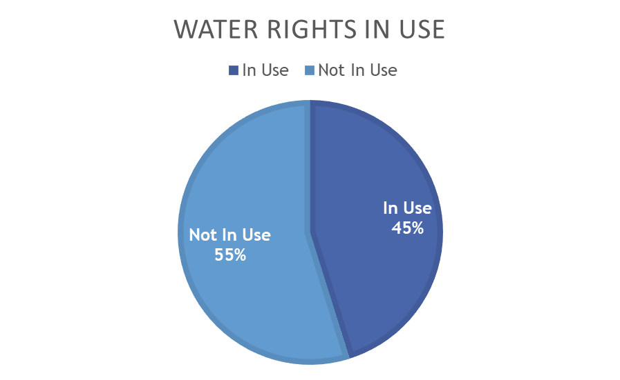

So, when I talk about acre feet, we use 160.8 acre-feet of water out of our 356 acre-feet of rights so we're only using about 45% of our water rights. One acre foot of water is 325,851 gallons so, when we look at the charts, and we see that we're at 52.4 million gallons pumped. We'll note here that's to 934 connections. That’s the number we are currently at today in the Riviera. Out of those connections, 887 of those are actual homes, and then we have 47 that are water connections to the parks, golf course, store, fire station, school, all the commercial properties. So, we're actually at 887 homes in our system at this time. That does not depict how much are actually in Riviera, because we do have several homes that are not in Riviera that we serve water to.

Okay, so as far as water testing, we're quite extensive. Already on all of that. Every month, two samples are drawn to test for coliform and whatever. And then what happens is, annually, Department of Health will send me a document stating, here's what you're going to test for, and it's random. We test everything that the City of Seattle tests for. We’re on the same testing regiment as any other Class A water system. So yes, those are all tested. Including, if anybody's been watching a lot of news, PFAS. [I] was asked about PFAS, so our first initial PFAS sample came back absolutely zero and non-detectable. I don't know that they test for necessarily a mineral content, because that's actually healthy in your water, but they look for anything that might be health effect, you know, the copper, the leads, the things like that. I do have that information available, so I can absolutely can get that for you. Referring to the lead and copper test, those are done every 3 years. Yes, those still are happening. That was the whole reason behind this particular treatment we had to do. We do not chlorinate, our system is not considered a treated system, but we control the pHs of the water.

Department of Ecology says Riviera, you have 356 acre-feet of water rights. We are the only system in Washington state in this unique situation, but I'll try to make it really simple. When we go to the Department of Health and we say, how many service connections. They count every service connection as a full-time resident. Everyone. So, when I went to them this time at 934 connections, they count that. They don't care how many gallons we're pumping. They say, well, you're using 934 connections. Then, they take the average from what they do in town. So, say each connection uses X amount of water, even though I was able to show, no, that's incorrect for us because many of them are using less. Part of the water rights that we dealt with this year was on the Department of Health side, so I went to Department of Health with all my documents, my pump records, with everything, and we sat down. The Department of Health is recognizing that 50% of our homes are part-time. After all doing all that, they accepted it. So, 250 more houses we can add as of right now on our water rights. The reason I didn't push, and when I say full-time houses, that's 500 or 600 total connections before we have to adjust it. I didn't push it too hard past that, because in 2028, we will start a new comprehensive water plan, and that'll be my time to battle.

What I'm going to do to prepare for that, we have Well 2 that was placed to be online 2 or 3 years ago, we just didn't need it yet. I've been kind of moving it along. So. I'm going to go ahead, not this next fiscal budget, but what I'll do is I'll put it in for the budget after this year. This money by the way, already has been collected for that project.

So what we'll do is, we'll move that well up, so that when I go in to do my comprehensive water plan, I have another source, which makes my argument more powerful, and in 2029 is when we should go in for approval. At that point, we should see that number increase, because you could look right at these numbers and see that we're doing fine. You can see that we're 45%. And I'm probably less than 50% pump runtime, so I mean, we're fine.

The question about the aquifer is a good one. We haven't done an aquifer performance study here in quite a while, but I can tell you that in the early 90s, we did do one. I'll give an example of one well. Well 7, we pumped it at 800 gallons a minute. And over 20 minutes, it dropped about 2 feet. We still had plenty of more we could have drawn it down before we got to where the pump's actually at. We shut it off. Within 15 minutes, it was already back up. Usually, I only pump 150 gallons a minute out of that pump. So, when the pump kicks on, it's not drawing much at all. So how do we get a lot of this data is we have sounders that are dropped down in the wellheads that go to a data logger, and we track it, so we're taking an aquifer level every 15 minutes, and I have it on a big graph that shows what's happening with the aquifer level, and it's keeping track of that. We see no decline, and I can go back 30. And we're still at the same. We have a very solid aquifer. The only thing I could see that could create a problem to build out would be, obviously, an earthquake or something of that nature.

When we had the Nisqually earthquake, we did see a drop, but it was only about 8 inches. It was literally minutes, and it refilled it, so that is all we really saw on that. There were areas in Long Branch, because I kind of checked around to see what was happening in the surrounding areas, but there were some areas in Long Branch that their wells went dry and never came back. We did not here. I think probably the island being an island setting is probably what saved us with a big earthquake like that, because in my head, from science, we know that the pressure of the salt water is holding in what falls on the island. So, as the rain falls on the island, it stays on the island.

Just to give you an idea, we get about 60 billion gallons of water that lands on Anderson Island each year. And then there's percentage of breakdowns. I've studied all the way back to 16 million years ago, when the Vashon ice came through, and that's kind of how I picked up some of these numbers. There's actually been studies from Anderson Island, clear back to 1921, and one of the reasons why it's a very attractive location for scientists is we have a lot of high banks on the water. That tells a whole lot about the geology and what's happened over the years. They've used Anderson Island as a study point for many years.

I mentioned the 50-50 split of full-time and part-time and then, the other thing I just want to emphasize, our primary, daily operations, and I'm sure you see them out there, is leak detection. That is an ongoing battle. And has been. I want to bring up the next slide.

This year, we actually had a situation with one of what I would call the worst breaks I've faced here at Riviera. And I don't know if you guys can see it, or if you look this picture,
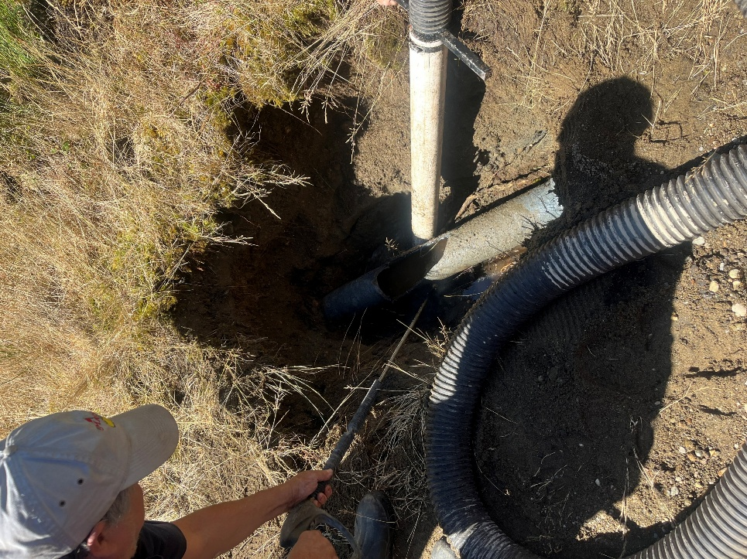

you'll see that the main fractured itself. It blew out. No roots, no nothing. It was just a failure. I can't determine if it was a manufacturer issue or not, when I tried to look at it. What I can tell you is, if you look really closely, you can kind of tell the rough texture on the pipe. Well, this pipe's supposed to be smooth. This pipe was soft on the outside. And I don't understand why the soils appear to be fine. I don't see any… if you look at a… when you're looking at surrounding areas, you look for a lot of maples, predominantly alders, very acidic, and that can deteriorate the pipe. But what happened put us on our first real official test of our emergency program.

Most main works, we just go right through it, and I need to put out a big thanks, because immediately, this happened and we had to shut down. I could tell that objects got into the pipe. Normally I keep on the pressure, and I don't get anything in the pipe. But this time I knew that we were going to have a problem. I could not guarantee the cleanliness. So, what we did was, is I immediately called the office, as we do on any leak, to make them aware that we have a leak in case anybody calls in, because their water's shut off. This incident, I called in, Dan, Bryanne, and Tanner immediately came out to the site. We brainstormed together on how to resolve it. Tanner, bless him, stayed there with us and helped us do the repairs on the pipe. Dan, and Bryanne went back and started formulating a communication plan. Once we got it going, the office was awesome. Everybody in the office, Bryanne: I'm going to always forget names, because I can't keep everybody; Dan, Ben… Bryanne, Christine, and Jessica. All immediately jumped in. We contacted every home that was in the area that we had to shut down, made sure they understood what was going on. And then we moved into the chlorination, and so I had to chlorinate this pipe, had to let it sit, flush it, so there was a pretty big chunk of time where people are out of water. When I say big chunk of time, it's about 5 hours. Then I was able to charge the pipe, but that's when we had to make sure everybody in that section knew, hey, you’ve got to boil water, don't drink the water. I'm pretty sure it's safe, but I can't guarantee it. Samples were drawn, taken to town. Takes 24 hours to get the read back to determine that it was coliform negative, which is the key test for E. coli. And it did, it came back clean, and everything was fine. The situation worked flawlessly. But what it did most of all is it made us take a look at our emergency response plan, specifically on main break. We found some areas that I did not put in and so we were able to correct that in our emergency response plan, and it was a great run at going through and, and it'll make the next one that much smoother. This one actually ran smooth the whole time. We didn't have an issue. It's just that when we went back to compare our actions to the plan, we're like, well, that's not what we did.

So anyway, I really appreciate the entire Riviera staff on this one, and all the help they did. And when it comes to communication on water, any water break, always remember, even a minor one, if we have to shut somebody's water off, or we know there's a loss of pressure we automatically contact the Riviera itself. So, if you're one of the homes that is being affected, absolutely call in to Riviera. We had a couple, late night repairs. If it's late night repair, the number is 253-884-4808. That's the number you call 24-7-365. I may not answer you immediately, but typically within 5 or 10 minutes, I'll get the response back. So that you know what's happening and why you don't have water. If the office is running, it's easy just to call the office. They will know what's going on, and they'll have an estimated time of repair.

BOT President: There was that one issue I think membership would like clarity on. Remember when the school had the issue with the water pipe because the contractor busted the pipe? You said we don't use chlorine in our water. Do you want to explain how that happened so people know in the future.

Russ: What I suspect happened was, the elementary school had to deal with lead and copper, and it's just a standard thing that's going on, but there was a detection within the school, nothing of health concern, but close enough that the Department of Health made them replace some piping, and I suspect what they did is, was when they made that replacement, they added a little chlorine and didn't get it all flushed out. So, the only time you should, you know, there's a potential of possible taste of chlorine in our system would be the scenario like this, where I actually had to shock chlorinate. But I always try to flush immensely before I turn on all the services and send the water to your tap. So that's what happened at the school. It wasn't through us that this chlorine entered the system.

